Section 6.1: Writing Equations

SOLs: The student will
A.1 Solve multistep linear equations and inequalities in one variable, solve literal equations (formulas) for a given variable, and apply these skills to solve practical problems ….

Objectives: Students will be able to:
Solve linear inequalities by using addition
Solve linear inequalities by using subtraction

Vocabulary:
Defining a variable – letting a variable represent one of the unspecified numbers in the problem
Formula – is an equation that states a rule for the relationship between certain quantities
Set-builder notation - a concise way of writing a solution set. For example, {t l t < 17} represents the set of all numbers t such that t is less than 17

Key Concept:
Examples:
- Solve s – 12 > 65. Then check your solution.

- Solve 12 ≥ y – 9. Then graph it on a number line.

- Solve q + 23 < 14. Then graph the solution.

- Solve 12n – 4 ≤ 13n. Then graph the solution.

- Write an inequality for the sentence below. Then solve the inequality.
Seven times a number is greater than 6 times that number minus two.

Concept Summary:
Variables are used to represent unknowns when writing equations
Formulas given in sentence form can be written as algebraic equations

Homework: pg 124: 14-38 even
Section 6.2: Solving Inequalities by Multiplication and Division

SOLs: The student will
A.1 Solve multistep linear equations and inequalities in one variable, solve literal equations (formulas) for a given variable, and apply these skills to solve practical problems ….

Objectives: Students will be able to:
Solve inequalities by using multiplication
Solve inequalities by using division

Vocabulary: none new

Key Concept:

Multiplying or dividing both sides of an inequality by a positive number does not change the inequality

Multiplying or dividing both sides of an inequality by a negative number “flips” the inequality

Examples:

- Solve: $\frac{g}{3}<\text{12}$. Then check your solution.

- Solve: $\frac{−3}{4}d≥6$. Then check your solution

- Write an inequality for the sentence below. Then solve the inequality.
Four-fifths of a number is at most twenty.

- Solve 12s ≥ 60

- Solve -8q < 136

Concept Summary:
If each side of a true inequality is multiplied or divided by the same positive number, the resulting inequality is also true
If each side of a true inequality is multiplied or divided by the same negative number, the direction of the inequality must be reserved

Homework: pg 132; 16-64 even
Section 6.3: Solving Multi-Step Inequalities

SOLs: The student will
A.1 Solve multistep linear equations and inequalities in one variable, solve literal equations (formulas) for a given variable, and apply these skills to solve practical problems …. .

Objectives: Students will be able to:
Solve inequalities involving more than one operation
Solve linear inequalities involving the Distributive Property

Vocabulary:
None new

Key Concept:

Examples:

- Science The inequality F > 212 represents the temperatures in degrees Fahrenheit for which water is a gas (steam). Similarly, the inequality $\frac{9}{5}C+\text{32}>\text{212}$represents the temperatures in degrees Celsius for which water is a gas. Find the temperature in degrees Celsius for which water is a gas.

- Solve 13 – 11d ≥ 79. Then check your solution.

- Write an inequality for the sentence below. Then solve the inequality.
Four times a number plus twelve is less than a number minus three.

- Solve: 8 – (c+3) ≤ 6c + 3(2 – c).

- Solve: -7(s + 4) + 11s ≥ 8s – 2(2s + 1)

Concept Summary:
Multi-step inequalities can be solved by undoing the operations
Remember to reverse the inequality sign when multiplying or dividing each side by a negative number
When solving equations that contain grouping symbols, first use the Distributive Property to remove the grouping symbols

Homework: pg 138; 14-40 even
Section 6.4: Solving Compound Inequalities

SOLs: The student will
A.1 Solve multistep linear equations and inequalities in one variable, solve literal equations (formulas) for a given variable, and apply these skills to solve practical problems. Graphing calculators will be used to confirm algebraic solutions.

Objectives: Students will be able to:
Solve compound inequalities containing the word ‘and’ and graph their solution sets
Solve compound inequalities containing the word ‘or’ and graph their solution sets

Vocabulary:
Compound inequality – two or more inequalities that are connected by the words ‘and’ or ‘or’
Intersection – the graph of a compound inequality containing ‘and’; the solution is the set of elements common to both inequalities
Union – the graph of a compound inequality containing ‘or’; the solution is a solution of either inequality, not necessarily both

Key Concept:

Examples:
- Graph the solution set of y ≥ 5 and y < 12

- Solve7 < z + 2 ≤ 11. Then graph the solution set.

- Travel: A ski resort has several types of hotel rooms and several types of cabins. The hotel rooms cost at most $89 per night and the cabins cost at least $109 per night. Write and graph a compound inequality that describes the amount that a quest would pay per night at the resort.

- Solve 4k – 7 ≤ 25 or 12 – 9k ≥ 30.

Concept Summary:
The solution of a compound inequality containing and is the intersection of the graphs of the two inequalities
The solution of a compound inequality containing or is the union of the graphs of the two inequalities

Homework: pg 145-6; 16-46 even
Section 6.5: Solving Open Sentences Involving Absolute Value

SOLs: The student will
A.1 Solve multistep linear equations and inequalities in one variable, solve literal equations (formulas) for a given variable, and apply these skills to solve practical problems. Graphing calculators will be used to confirm algebraic solutions.

Objectives: Students will be able to:
Solve absolute value equations
Solve absolute value inequalities

Vocabulary: none new

Key Concept:

Examples:

- Solve |b + 6| = 5

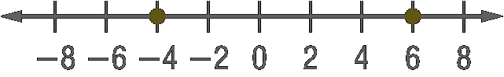
- Write an equation involving the absolute value for the graph.

- Solve |s – 3| ≤ 12 and then graph the solution set.

- Solve |3y – 3| > 9 and then graph the solution set

Concept Summary:
If |x| = n, then x = -n or x = n
If |x| < n, then x = -n or x = n (inside)
If |x| > n, then x = -n or x = n (outside)

Homework: pg 152-3; 16-42 even
Section 6.6: Graphing Inequalities in Two Variables

SOLs: The student will
A.1 Solve multistep linear equations and inequalities in one variable, solve literal equations (formulas) for a given variable, and apply these skills to solve practical problems. Graphing calculators will be used to confirm algebraic solutions.

Objectives: Students will be able to:
Graph inequalities on the coordinate plane
Solve real-world problems involving linear inequalities

Vocabulary:
Half-plane – the region of the graph of an inequality on one side of a boundary
Boundary – a line or curve that separates the coordinate plane into regions

Key Concept: To graph an inequality in two variables
Step 1: Determine the boundary and draw a dashed or solid line
Step 2: Select a test point. Test that point.
Step 3: Shade the half-plane that contains the solution
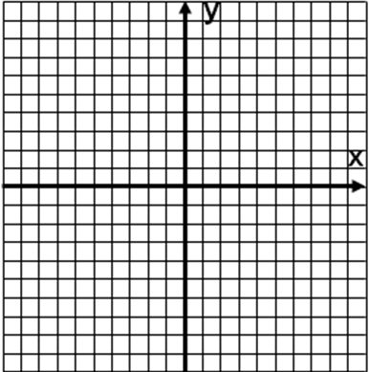
Examples:
- From the set {(3, 3), (0, 2), (2, 4), (1, 0)}, which ordered pairs are part of the solution set for4x + 2y > 8?

- Graph 2y – 4x > 6

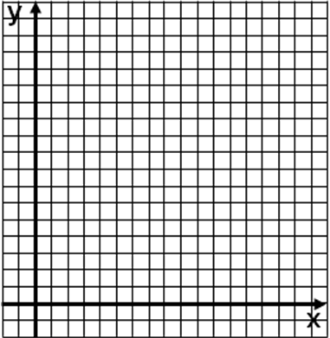
- Journalism: Lee Cooper writes and edits short articles for a local newspaper. It generally takes her an hour to write an article and about a half-hour to edit an article. If Lee works up to 8 hours a day, how many articles can she write and edit in one day?

Concept Summary:
To graph an inequality in two variables
Step 1: Determine the boundary and draw a dashed or solid line
Step 2: Select a test point. Test that point.
Step 3: Shade the half-plane that contains the solution

Homework: pg 158: 12-32 even
Section 6.R: Review

SOLs: The student will

Objectives: Students will be able to:

Vocabulary:

Key Concept:

Examples:

Concept Summary:

Homework: none

